**TIME COMPLEXITY :**

একটি প্রোগ্রাম চলতে কি রকম সময় লাগে সেটা নির্ণয় করাকেই time complexity বলে।

যেসব function or operation এর time complexity ধরা হয়

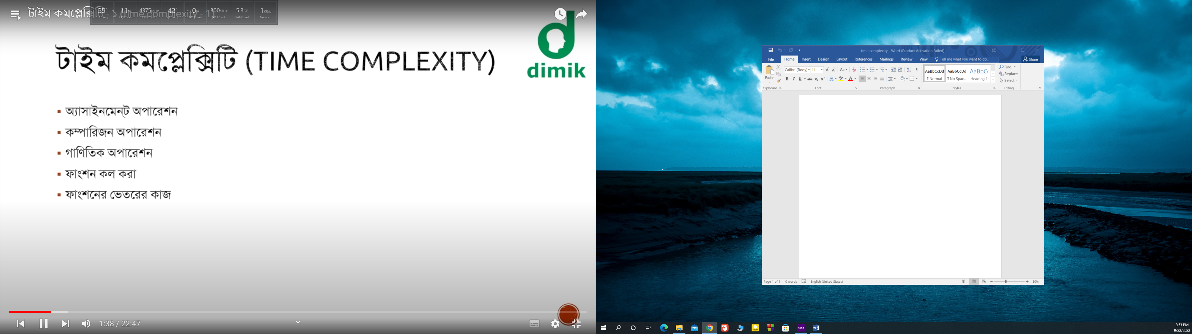

Big O notation / O( ) :

---

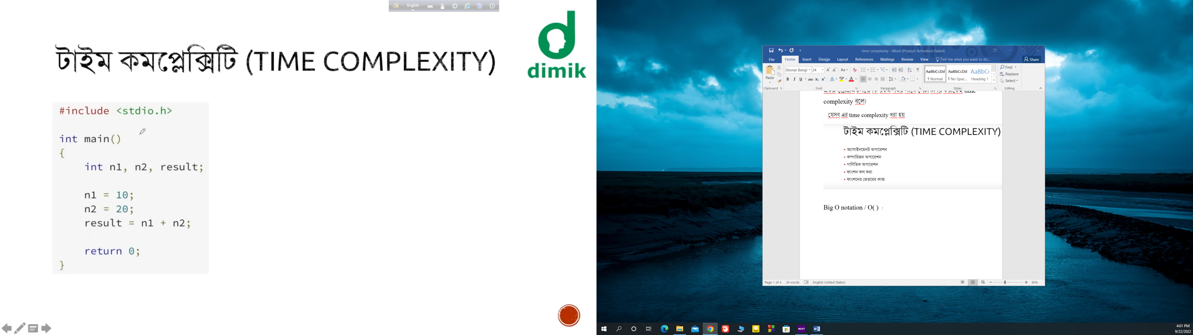

Complexity === O(1)

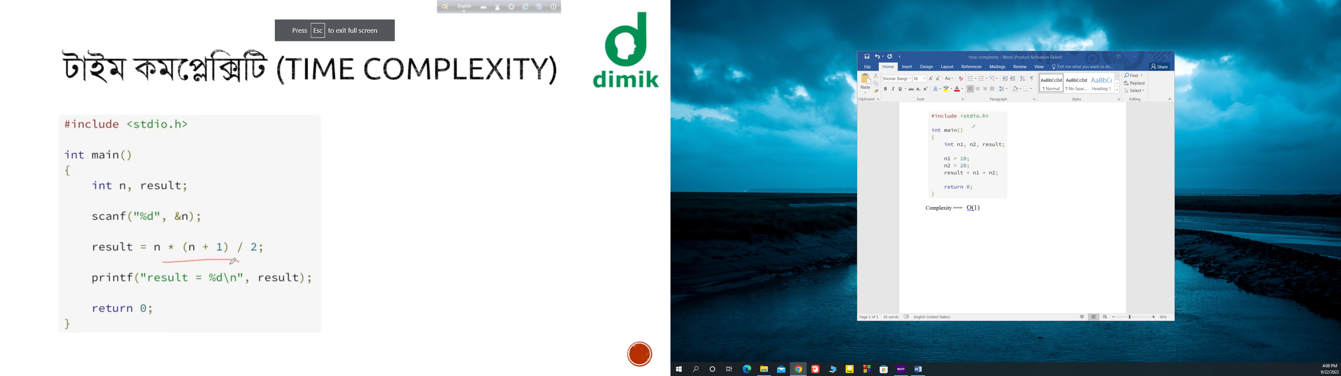

Complexity= O(1)

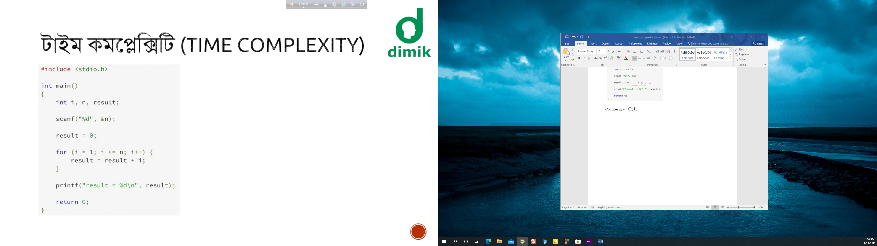

Complexity= O(n)

////// cause the loop is dependent on loops if the n=100 the operation of the loop is 200 …… that means O(2n)= 2O(n)= O(n)

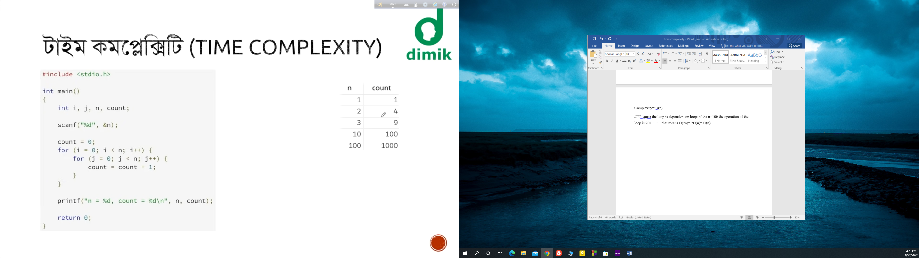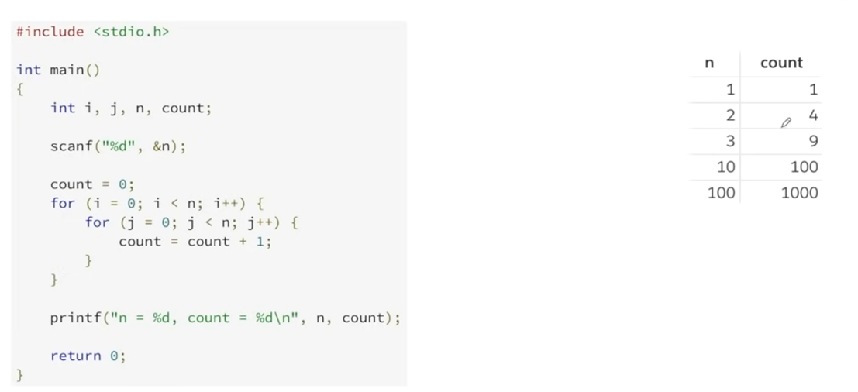

Complexity : O( n^2)

///there is a nested loop and the loop is dependent to n. If the n is 2 the operation will done to 4. If the n=100 the operation will done to 10000

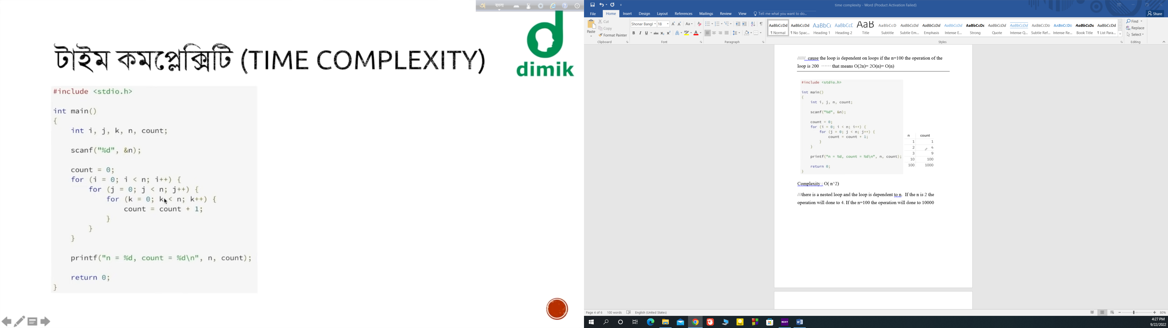

Complexity : O( n^3 )

////// cause there is 3 nested loops and each loop is dependent to n

Time complexity :

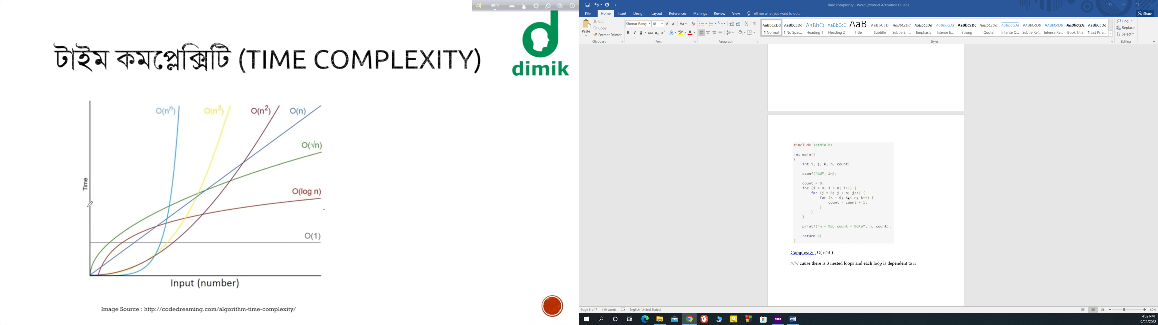

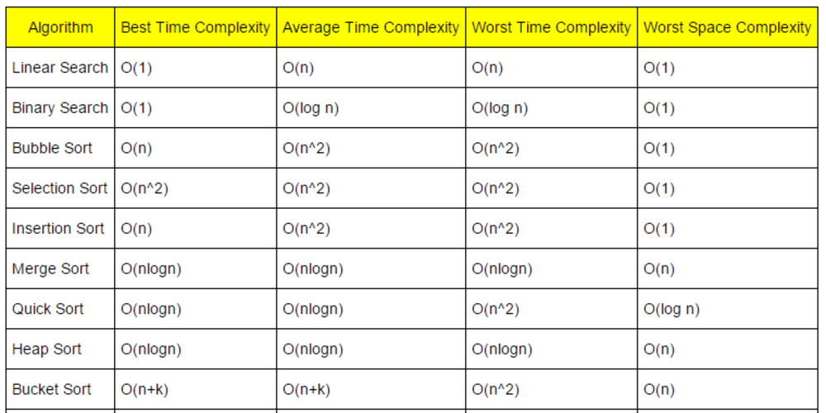

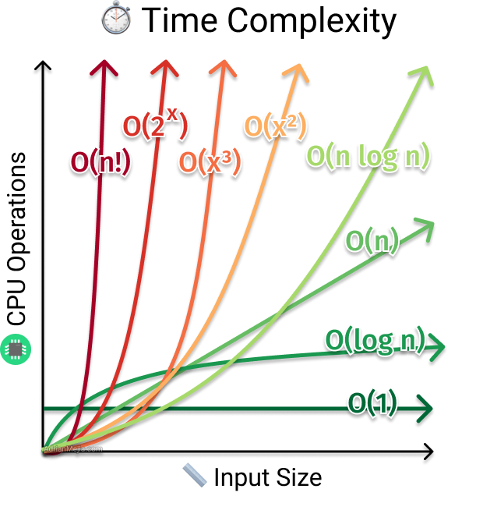

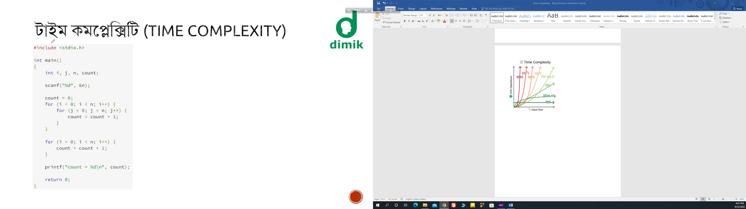

Complexity : O(n^2) not O( n^2 +n)

***** if O( 4*n^4 + 2*n^3 + 3n) = then O( n^4)